|  |
| --- |
| The SAS System |

The REG Procedure

Model: MODEL1

Dependent Variable: Crime

|  |  |
| --- | --- |
| **Number of Observations Read** | 47 |
| **Number of Observations Used** | 47 |

| **Analysis of Variance** | | | | | |
| --- | --- | --- | --- | --- | --- |
| **Source** | **DF** | **Sum of Squares** | **Mean Square** | **F Value** | **Pr > F** |
| **Model** | 6 | 3333016 | 555503 | 6.26 | 0.0001 |
| **Error** | 40 | 3547911 | 88698 |  |  |
| **Corrected Total** | 46 | 6880928 |  |  |  |

|  |  |  |  |
| --- | --- | --- | --- |
| **Root MSE** | 297.82173 | **R-Square** | 0.4844 |
| **Dependent Mean** | 905.08511 | **Adj R-Sq** | 0.4070 |
| **Coeff Var** | 32.90538 |  |  |

| **Parameter Estimates** | | | | | |
| --- | --- | --- | --- | --- | --- |
| **Variable** | **DF** | **Parameter Estimate** | **Standard Error** | **t Value** | **Pr > |t|** |
| **Intercept** | **1** | -1490.58723 | 778.73581 | -1.91 | 0.0628 |
| **Prob** | **1** | -3620.40319 | 2385.99954 | -1.52 | 0.1370 |
| **Wealth** | **1** | -0.07407 | 0.08822 | -0.84 | 0.4061 |
| **ur** | **1** | 27.86975 | 9.90831 | 2.81 | 0.0076 |
| **Pop** | **1** | 0.32203 | 1.42249 | 0.23 | 0.8221 |
| **police** | **1** | 346.98624 | 131.12757 | 2.65 | 0.0116 |
| **Ed** | **1** | 169.04152 | 73.86792 | 2.29 | 0.0275 |

|  |
| --- |
| The SAS System |

The REG Procedure

Model: MODEL1

Dependent Variable: Crime

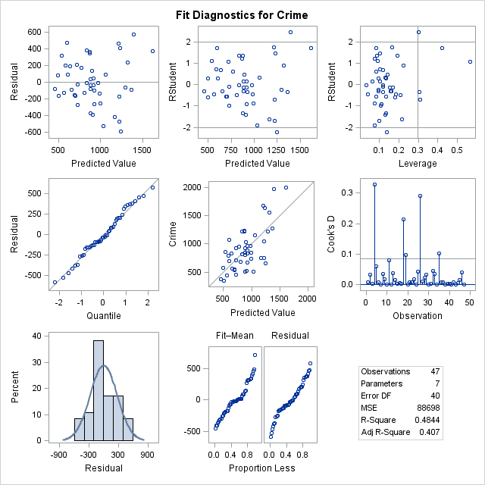

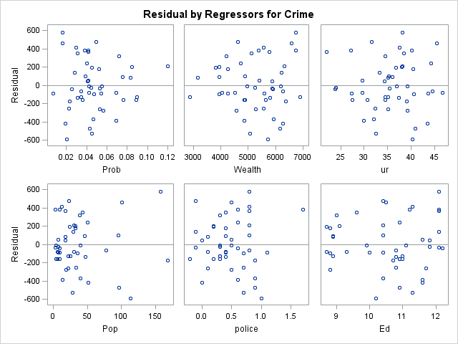

*No Interaction between so and prob

|  |
| --- |
| The SAS System |

The REG Procedure

Model: MODEL1

Dependent Variable: Crime

|  |  |
| --- | --- |
| **Number of Observations Read** | 47 |
| **Number of Observations Used** | 47 |

| **Analysis of Variance** | | | | | |
| --- | --- | --- | --- | --- | --- |
| **Source** | **DF** | **Sum of Squares** | **Mean Square** | **F Value** | **Pr > F** |
| **Model** | 3 | 1602461 | 534154 | 4.35 | 0.0092 |
| **Error** | 43 | 5278467 | 122755 |  |  |
| **Corrected Total** | 46 | 6880928 |  |  |  |

|  |  |  |  |
| --- | --- | --- | --- |
| **Root MSE** | 350.36417 | **R-Square** | 0.2329 |
| **Dependent Mean** | 905.08511 | **Adj R-Sq** | 0.1794 |
| **Coeff Var** | 38.71063 |  |  |

| **Parameter Estimates** | | | | | |
| --- | --- | --- | --- | --- | --- |
| **Variable** | **DF** | **Parameter Estimate** | **Standard Error** | **t Value** | **Pr > |t|** |
| **Intercept** | **1** | 1383.95168 | 152.19325 | 9.09 | <.0001 |
| **Prob** | **1** | -11787 | 3598.16088 | -3.28 | 0.0021 |
| **So** | **1** | -177.63967 | 310.52137 | -0.57 | 0.5703 |
| **sop** | **1** | 6301.52541 | 5394.84339 | 1.17 | 0.2492 |

|  |
| --- |
| The SAS System |

The REG Procedure

Model: MODEL1

Dependent Variable: Crime

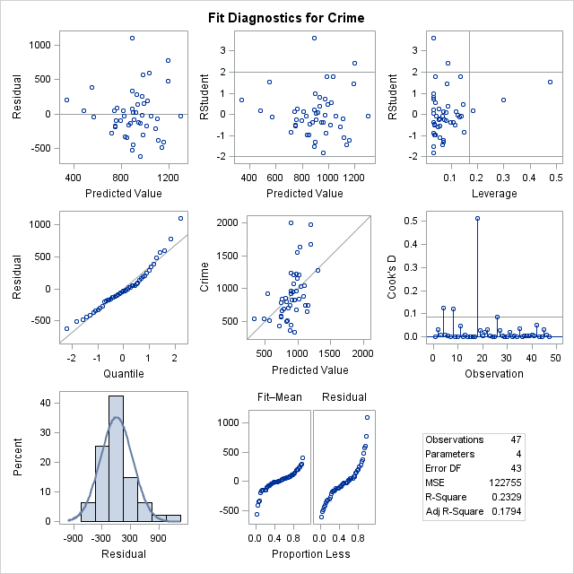

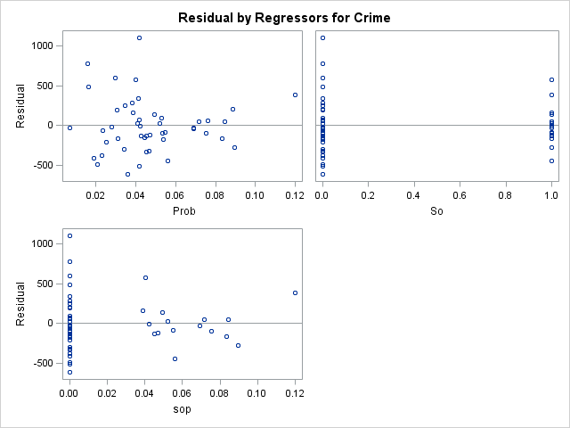

|  |
| --- |
| The SAS System |

The REG Procedure

Model: MODEL1

Dependent Variable: Crime

|  |  |
| --- | --- |
| **Number of Observations Read** | 47 |
| **Number of Observations Used** | 47 |

| **Analysis of Variance** | | | | | |
| --- | --- | --- | --- | --- | --- |
| **Source** | **DF** | **Sum of Squares** | **Mean Square** | **F Value** | **Pr > F** |
| **Model** | 4 | 2522506 | 630626 | 6.08 | 0.0006 |
| **Error** | 42 | 4358422 | 103772 |  |  |
| **Corrected Total** | 46 | 6880928 |  |  |  |

|  |  |  |  |
| --- | --- | --- | --- |
| **Root MSE** | 322.13654 | **R-Square** | 0.3666 |
| **Dependent Mean** | 905.08511 | **Adj R-Sq** | 0.3063 |
| **Coeff Var** | 35.59185 |  |  |

| **Parameter Estimates** | | | | | |
| --- | --- | --- | --- | --- | --- |
| **Variable** | **DF** | **Parameter Estimate** | **Standard Error** | **t Value** | **Pr > |t|** |
| **Intercept** | **1** | -505.10948 | 615.90955 | -0.82 | 0.4168 |
| **Prob** | **1** | -5476.85090 | 2718.94311 | -2.01 | 0.0504 |
| **Wealth** | **1** | 0.28925 | 0.09873 | 2.93 | 0.0055 |
| **So** | **1** | 1131.75220 | 672.37363 | 1.68 | 0.0998 |
| **sowealth** | **1** | -0.15786 | 0.13286 | -1.19 | 0.2415 |

|  |
| --- |
| The SAS System |

The REG Procedure

Model: MODEL1

Dependent Variable: Crime

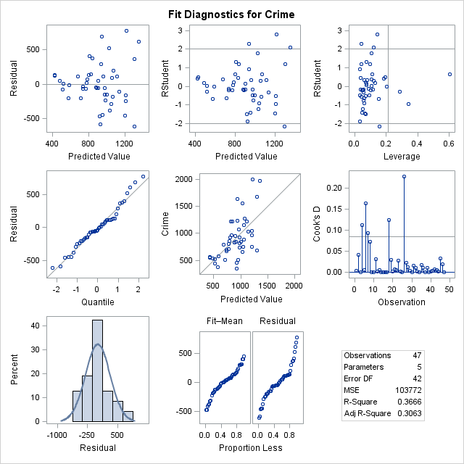

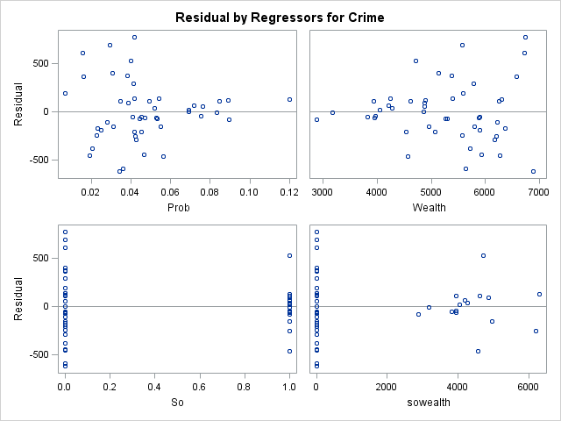

|  |
| --- |
| The SAS System |

The REG Procedure

Model: MODEL1

Dependent Variable: Crime

|  |  |
| --- | --- |
| **Number of Observations Read** | 47 |
| **Number of Observations Used** | 47 |

| **Analysis of Variance** | | | | | |
| --- | --- | --- | --- | --- | --- |
| **Source** | **DF** | **Sum of Squares** | **Mean Square** | **F Value** | **Pr > F** |
| **Model** | 4 | 1931832 | 482958 | 4.10 | 0.0068 |
| **Error** | 42 | 4949096 | 117836 |  |  |
| **Corrected Total** | 46 | 6880928 |  |  |  |

|  |  |  |  |
| --- | --- | --- | --- |
| **Root MSE** | 343.27191 | **R-Square** | 0.2808 |
| **Dependent Mean** | 905.08511 | **Adj R-Sq** | 0.2123 |
| **Coeff Var** | 37.92703 |  |  |

| **Parameter Estimates** | | | | | |
| --- | --- | --- | --- | --- | --- |
| **Variable** | **DF** | **Parameter Estimate** | **Standard Error** | **t Value** | **Pr > |t|** |
| **Intercept** | **1** | 489.53372 | 407.21298 | 1.20 | 0.2360 |
| **Prob** | **1** | -7184.64911 | 2770.19938 | -2.59 | 0.0130 |
| **ur** | **1** | 20.86905 | 10.39211 | 2.01 | 0.0511 |
| **So** | **1** | 385.99739 | 957.62360 | 0.40 | 0.6889 |
| **sour** | **1** | -9.32175 | 25.35777 | -0.37 | 0.7150 |

|  |
| --- |
| The SAS System |

The REG Procedure

Model: MODEL1

Dependent Variable: Crime

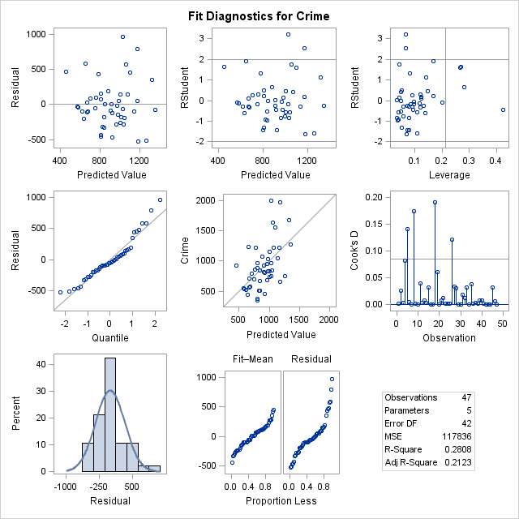

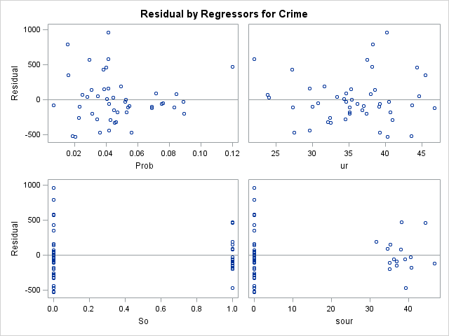

|  |
| --- |
| The SAS System |

The REG Procedure

Model: MODEL1

Dependent Variable: Crime

|  |  |
| --- | --- |
| **Number of Observations Read** | 47 |
| **Number of Observations Used** | 47 |

| **Analysis of Variance** | | | | | |
| --- | --- | --- | --- | --- | --- |
| **Source** | **DF** | **Sum of Squares** | **Mean Square** | **F Value** | **Pr > F** |
| **Model** | 4 | 1685470 | 421367 | 3.41 | 0.0168 |
| **Error** | 42 | 5195458 | 123701 |  |  |
| **Corrected Total** | 46 | 6880928 |  |  |  |

|  |  |  |  |
| --- | --- | --- | --- |
| **Root MSE** | 351.71206 | **R-Square** | 0.2449 |
| **Dependent Mean** | 905.08511 | **Adj R-Sq** | 0.1730 |
| **Coeff Var** | 38.85956 |  |  |

| **Parameter Estimates** | | | | | |
| --- | --- | --- | --- | --- | --- |
| **Variable** | **DF** | **Parameter Estimate** | **Standard Error** | **t Value** | **Pr > |t|** |
| **Intercept** | **1** | 1151.87679 | 156.62972 | 7.35 | <.0001 |
| **Prob** | **1** | -7463.47004 | 2910.87422 | -2.56 | 0.0140 |
| **Pop** | **1** | 1.72676 | 1.52954 | 1.13 | 0.2653 |
| **So** | **1** | 35.98626 | 210.42275 | 0.17 | 0.8650 |
| **sopop** | **1** | 2.52227 | 4.73568 | 0.53 | 0.5971 |

|  |
| --- |
| The SAS System |

The REG Procedure

Model: MODEL1

Dependent Variable: Crime

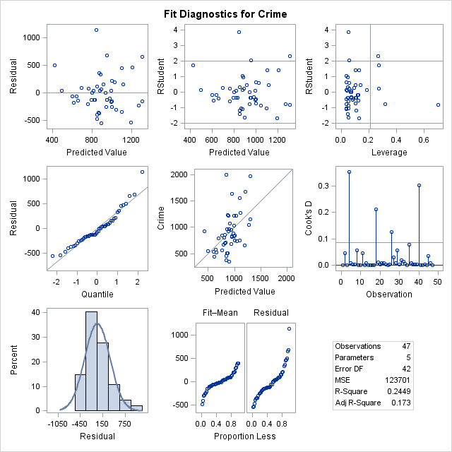

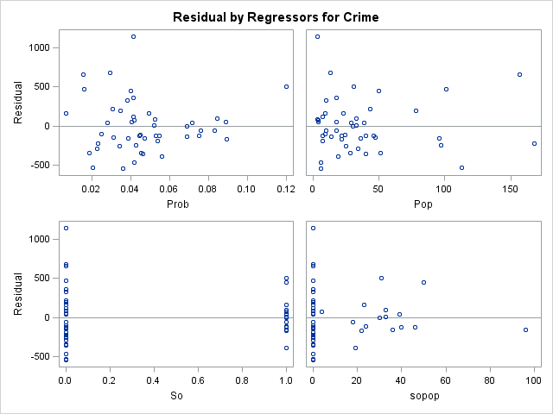

|  |
| --- |
| The SAS System |

The REG Procedure

Model: MODEL1

Dependent Variable: Crime

|  |  |
| --- | --- |
| **Number of Observations Read** | 47 |
| **Number of Observations Used** | 47 |

| **Analysis of Variance** | | | | | |
| --- | --- | --- | --- | --- | --- |
| **Source** | **DF** | **Sum of Squares** | **Mean Square** | **F Value** | **Pr > F** |
| **Model** | 4 | 2577035 | 644259 | 6.29 | 0.0005 |
| **Error** | 42 | 4303893 | 102474 |  |  |
| **Corrected Total** | 46 | 6880928 |  |  |  |

|  |  |  |  |
| --- | --- | --- | --- |
| **Root MSE** | 320.11504 | **R-Square** | 0.3745 |
| **Dependent Mean** | 905.08511 | **Adj R-Sq** | 0.3149 |
| **Coeff Var** | 35.36850 |  |  |

| **Parameter Estimates** | | | | | |
| --- | --- | --- | --- | --- | --- |
| **Variable** | **DF** | **Parameter Estimate** | **Standard Error** | **t Value** | **Pr > |t|** |
| **Intercept** | **1** | 980.38499 | 143.63238 | 6.83 | <.0001 |
| **Prob** | **1** | -7453.56465 | 2495.70241 | -2.99 | 0.0047 |
| **police** | **1** | 458.55104 | 142.18187 | 3.23 | 0.0024 |
| **So** | **1** | 236.62429 | 187.18258 | 1.26 | 0.2132 |
| **sopolice** | **1** | -171.82638 | 362.90214 | -0.47 | 0.6383 |

|  |
| --- |
| The SAS System |

The REG Procedure

Model: MODEL1

Dependent Variable: Crime

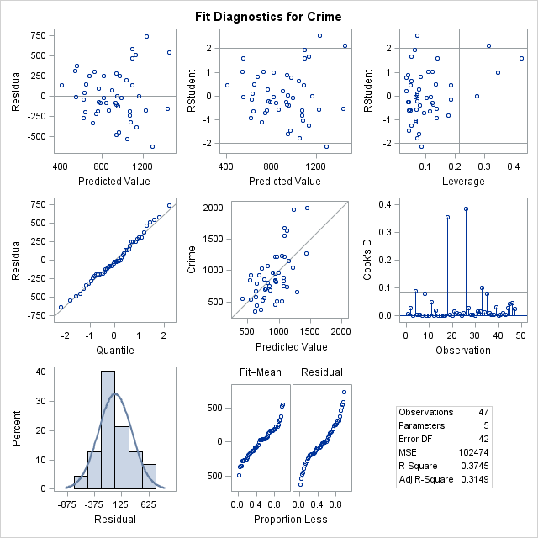

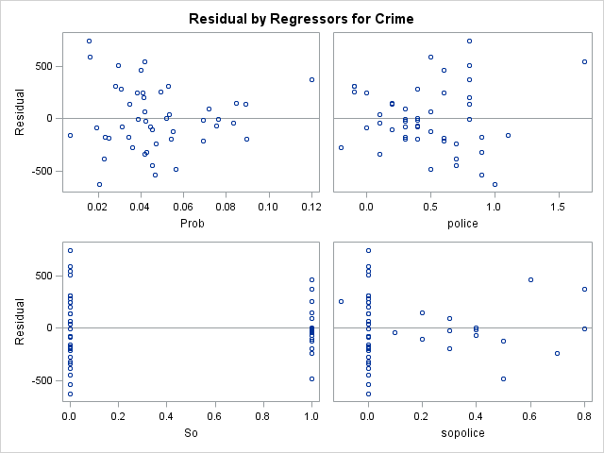

|  |
| --- |
| The SAS System |

The REG Procedure

Model: MODEL1

Dependent Variable: Crime

|  |  |
| --- | --- |
| **Number of Observations Read** | 47 |
| **Number of Observations Used** | 47 |

| **Analysis of Variance** | | | | | |
| --- | --- | --- | --- | --- | --- |
| **Source** | **DF** | **Sum of Squares** | **Mean Square** | **F Value** | **Pr > F** |
| **Model** | 4 | 2286964 | 571741 | 5.23 | 0.0016 |
| **Error** | 42 | 4593963 | 109380 |  |  |
| **Corrected Total** | 46 | 6880928 |  |  |  |

|  |  |  |  |
| --- | --- | --- | --- |
| **Root MSE** | 330.72660 | **R-Square** | 0.3324 |
| **Dependent Mean** | 905.08511 | **Adj R-Sq** | 0.2688 |
| **Coeff Var** | 36.54094 |  |  |

| **Parameter Estimates** | | | | | |
| --- | --- | --- | --- | --- | --- |
| **Variable** | **DF** | **Parameter Estimate** | **Standard Error** | **t Value** | **Pr > |t|** |
| **Intercept** | **1** | -648.01689 | 874.36438 | -0.74 | 0.4627 |
| **Prob** | **1** | -8797.81205 | 2570.16727 | -3.42 | 0.0014 |
| **Ed** | **1** | 172.33805 | 78.69873 | 2.19 | 0.0341 |
| **So** | **1** | 462.83838 | 1310.90998 | 0.35 | 0.7258 |
| **soed** | **1** | -3.31780 | 127.56337 | -0.03 | 0.9794 |

|  |
| --- |
| The SAS System |

The REG Procedure

Model: MODEL1

Dependent Variable: Crime

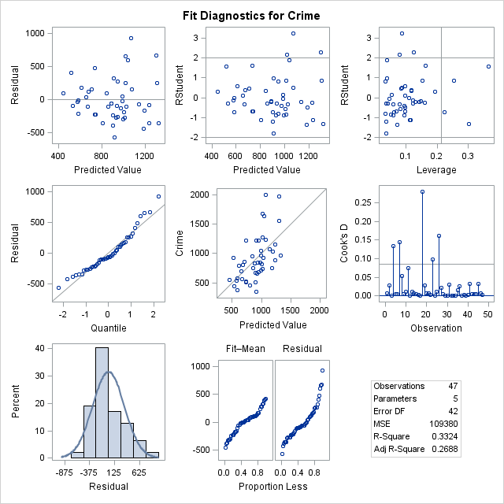

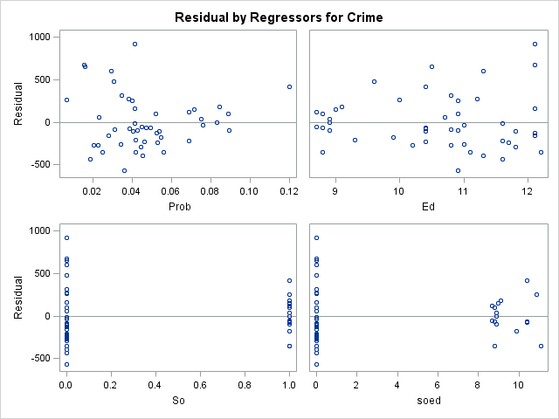

|  |
| --- |
| The SAS System |

The REG Procedure

Model: MODEL1

Dependent Variable: Crime

|  |  |
| --- | --- |
| **Number of Observations Read** | 47 |
| **Number of Observations Used** | 47 |

| **Analysis of Variance** | | | | | |
| --- | --- | --- | --- | --- | --- |
| **Source** | **DF** | **Sum of Squares** | **Mean Square** | **F Value** | **Pr > F** |
| **Model** | 2 | 1268456 | 634228 | 4.97 | 0.0113 |
| **Error** | 44 | 5612472 | 127556 |  |  |
| **Corrected Total** | 46 | 6880928 |  |  |  |

|  |  |  |  |
| --- | --- | --- | --- |
| **Root MSE** | 357.15008 | **R-Square** | 0.1843 |
| **Dependent Mean** | 905.08511 | **Adj R-Sq** | 0.1473 |
| **Coeff Var** | 39.46039 |  |  |

| **Parameter Estimates** | | | | | |
| --- | --- | --- | --- | --- | --- |
| **Variable** | **DF** | **Parameter Estimate** | **Standard Error** | **t Value** | **Pr > |t|** |
| **Intercept** | **1** | 1328.86662 | 298.11329 | 4.46 | <.0001 |
| **Prob** | **1** | -7605.96938 | 2573.83103 | -2.96 | 0.0050 |
| **Time** | **1** | -2.46658 | 8.25765 | -0.30 | 0.7666 |

|  |
| --- |
| The SAS System |

The REG Procedure

Model: MODEL1

Dependent Variable: Crime

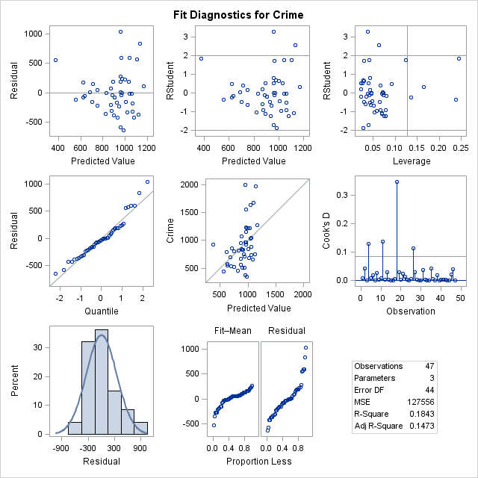

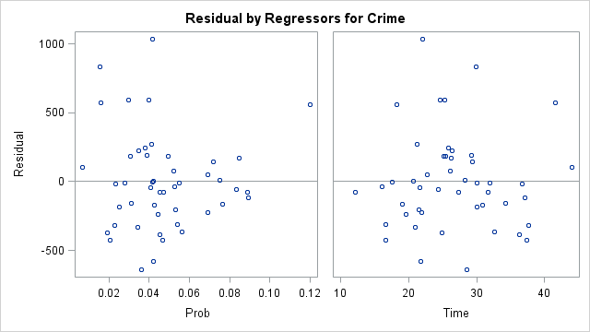

|  |
| --- |
| The SAS System |

The REG Procedure

Model: MODEL1

Dependent Variable: Crime

|  |  |
| --- | --- |
| **Number of Observations Read** | 47 |
| **Number of Observations Used** | 47 |

| **Analysis of Variance** | | | | | |
| --- | --- | --- | --- | --- | --- |
| **Source** | **DF** | **Sum of Squares** | **Mean Square** | **F Value** | **Pr > F** |
| **Model** | 3 | 1671084 | 557028 | 4.60 | 0.0071 |
| **Error** | 43 | 5209844 | 121159 |  |  |
| **Corrected Total** | 46 | 6880928 |  |  |  |

|  |  |  |  |
| --- | --- | --- | --- |
| **Root MSE** | 348.07924 | **R-Square** | 0.2429 |
| **Dependent Mean** | 905.08511 | **Adj R-Sq** | 0.1900 |
| **Coeff Var** | 38.45818 |  |  |

| **Parameter Estimates** | | | | | |
| --- | --- | --- | --- | --- | --- |
| **Variable** | **DF** | **Parameter Estimate** | **Standard Error** | **t Value** | **Pr > |t|** |
| **Intercept** | **1** | 481.89978 | 583.91207 | 0.83 | 0.4138 |
| **Prob** | **1** | -4487.79405 | 2715.69097 | -1.65 | 0.1057 |
| **Wealth** | **1** | 0.11625 | 0.08704 | 1.34 | 0.1887 |
| **Ed** | **1** | 2.25185 | 67.80302 | 0.03 | 0.9737 |
| The SAS System | | | | | |

The REG Procedure

Model: MODEL1

Dependent Variable: Crime

|  |  |
| --- | --- |
| **Number of Observations Read** | 47 |
| **Number of Observations Used** | 47 |

| **Analysis of Variance** | | | | | |
| --- | --- | --- | --- | --- | --- |
| **Source** | **DF** | **Sum of Squares** | **Mean Square** | **F Value** | **Pr > F** |
| **Model** | 3 | 1671084 | 557028 | 4.60 | 0.0071 |
| **Error** | 43 | 5209844 | 121159 |  |  |
| **Corrected Total** | 46 | 6880928 |  |  |  |

|  |  |  |  |
| --- | --- | --- | --- |
| **Root MSE** | 348.07924 | **R-Square** | 0.2429 |
| **Dependent Mean** | 905.08511 | **Adj R-Sq** | 0.1900 |
| **Coeff Var** | 38.45818 |  |  |

| **Parameter Estimates** | | | | | |
| --- | --- | --- | --- | --- | --- |
| **Variable** | **DF** | **Parameter Estimate** | **Standard Error** | **t Value** | **Pr > |t|** |
| **Intercept** | **1** | 481.89978 | 583.91207 | 0.83 | 0.4138 |
| **Prob** | **1** | -4487.79405 | 2715.69097 | -1.65 | 0.1057 |
| **Wealth** | **1** | 0.11625 | 0.08704 | 1.34 | 0.1887 |
| **Ed** | **1** | 2.25185 | 67.80302 | 0.03 | 0.9737 |

|  |
| --- |
| The SAS System |

The REG Procedure

Model: MODEL1

Dependent Variable: Crime

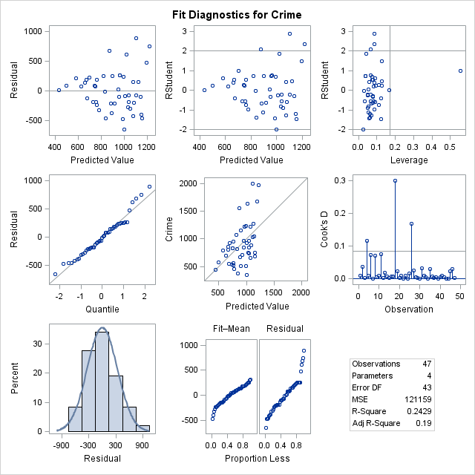

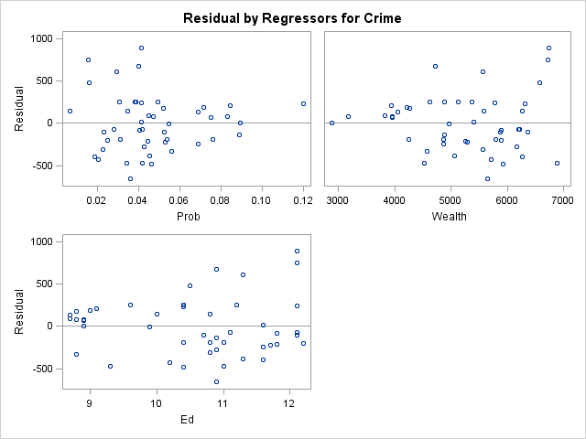

|  |
| --- |
| The SAS System |

The REG Procedure

Model: MODEL1

Dependent Variable: Crime

|  |  |
| --- | --- |
| **Number of Observations Read** | 47 |
| **Number of Observations Used** | 47 |

| **Analysis of Variance** | | | | | |
| --- | --- | --- | --- | --- | --- |
| **Source** | **DF** | **Sum of Squares** | **Mean Square** | **F Value** | **Pr > F** |
| **Model** | 4 | 2104217 | 526054 | 4.63 | 0.0035 |
| **Error** | 42 | 4776711 | 113731 |  |  |
| **Corrected Total** | 46 | 6880928 |  |  |  |

|  |  |  |  |
| --- | --- | --- | --- |
| **Root MSE** | 337.24059 | **R-Square** | 0.3058 |
| **Dependent Mean** | 905.08511 | **Adj R-Sq** | 0.2397 |
| **Coeff Var** | 37.26065 |  |  |

| **Parameter Estimates** | | | | | |
| --- | --- | --- | --- | --- | --- |
| **Variable** | **DF** | **Parameter Estimate** | **Standard Error** | **t Value** | **Pr > |t|** |
| **Intercept** | **1** | 5890.92658 | 2828.86029 | 2.08 | 0.0434 |
| **Prob** | **1** | -4613.25703 | 2631.91387 | -1.75 | 0.0869 |
| **Wealth** | **1** | -0.97010 | 0.56302 | -1.72 | 0.0922 |
| **Ed** | **1** | -535.31951 | 283.18903 | -1.89 | 0.0656 |
| **wealthed** | **1** | 0.10631 | 0.05448 | 1.95 | 0.0577 |

|  |
| --- |
| The SAS System |

The REG Procedure

Model: MODEL1

Dependent Variable: Crime

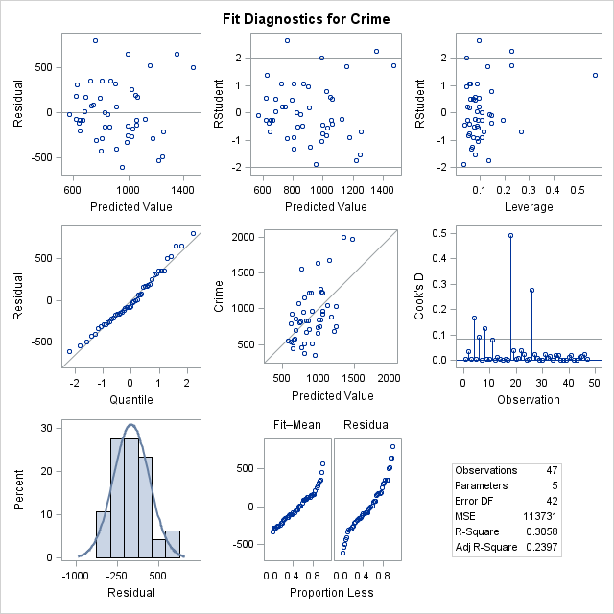

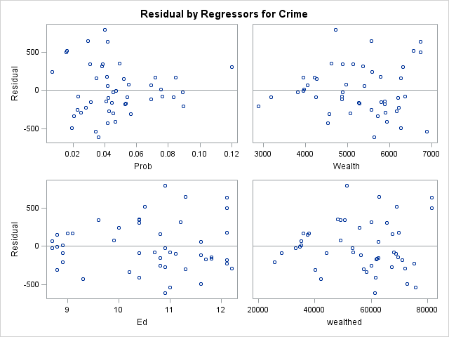

|  |
| --- |
| The SAS System |

The REG Procedure

Model: MODEL1

Dependent Variable: Crime





|  |
| --- |
| The SAS System |

The REG Procedure

Model: MODEL1

Dependent Variable: Crime

|  |  |
| --- | --- |
| **Number of Observations Read** | 47 |
| **Number of Observations Used** | 47 |

| **Analysis of Variance** | | | | | |
| --- | --- | --- | --- | --- | --- |
| **Source** | **DF** | **Sum of Squares** | **Mean Square** | **F Value** | **Pr > F** |
| **Model** | 3 | 1652137 | 550712 | 4.53 | 0.0076 |
| **Error** | 43 | 5228790 | 121600 |  |  |
| **Corrected Total** | 46 | 6880928 |  |  |  |

|  |  |  |  |
| --- | --- | --- | --- |
| **Root MSE** | 348.71159 | **R-Square** | 0.2401 |
| **Dependent Mean** | 905.08511 | **Adj R-Sq** | 0.1871 |
| **Coeff Var** | 38.52804 |  |  |

| **Parameter Estimates** | | | | | |
| --- | --- | --- | --- | --- | --- |
| **Variable** | **DF** | **Parameter Estimate** | **Standard Error** | **t Value** | **Pr > |t|** |
| **Intercept** | **1** | -1225.30891 | 1488.12847 | -0.82 | 0.4148 |
| **Prob** | **1** | 27844 | 26732 | 1.04 | 0.3034 |
| **Ed** | **1** | 228.94519 | 139.06372 | 1.65 | 0.1070 |
| **probed** | **1** | -3279.03941 | 2575.25415 | -1.27 | 0.2098 |

|  |
| --- |
| The SAS System |

The REG Procedure

Model: MODEL1

Dependent Variable: Crime

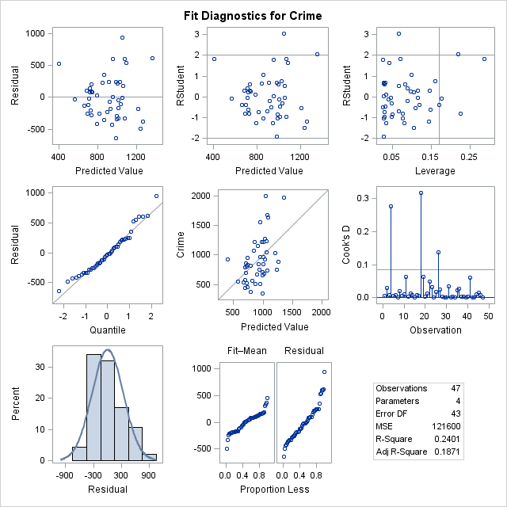

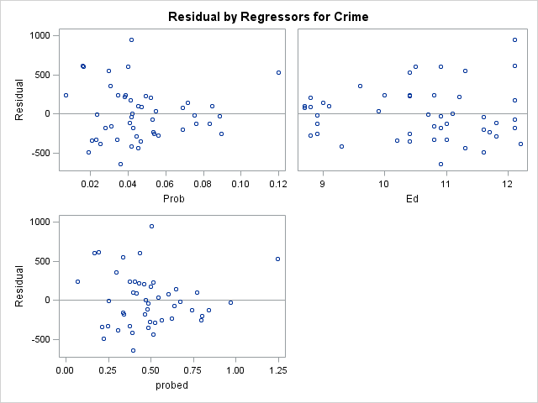

|  |
| --- |
| The SAS System |

The REG Procedure

Model: MODEL1

Dependent Variable: Crime

|  |  |
| --- | --- |
| **Number of Observations Read** | 47 |
| **Number of Observations Used** | 47 |

| **Analysis of Variance** | | | | | |
| --- | --- | --- | --- | --- | --- |
| **Source** | **DF** | **Sum of Squares** | **Mean Square** | **F Value** | **Pr > F** |
| **Model** | 4 | 1702817 | 425704 | 3.45 | 0.0158 |
| **Error** | 42 | 5178110 | 123288 |  |  |
| **Corrected Total** | 46 | 6880928 |  |  |  |

|  |  |  |  |
| --- | --- | --- | --- |
| **Root MSE** | 351.12439 | **R-Square** | 0.2475 |
| **Dependent Mean** | 905.08511 | **Adj R-Sq** | 0.1758 |
| **Coeff Var** | 38.79463 |  |  |

| **Parameter Estimates** | | | | | |
| --- | --- | --- | --- | --- | --- |
| **Variable** | **DF** | **Parameter Estimate** | **Standard Error** | **t Value** | **Pr > |t|** |
| **Intercept** | **1** | 91.10356 | 969.68192 | 0.09 | 0.9256 |
| **Prob** | **1** | 1969.99923 | 13020 | 0.15 | 0.8805 |
| **Wealth** | **1** | 0.18598 | 0.16311 | 1.14 | 0.2606 |
| **Ed** | **1** | 1.77868 | 68.40255 | 0.03 | 0.9794 |
| **probwealth** | **1** | -1.16656 | 2.29936 | -0.51 | 0.6146 |

|  |
| --- |
| The SAS System |

The REG Procedure

Model: MODEL1

Dependent Variable: Crime

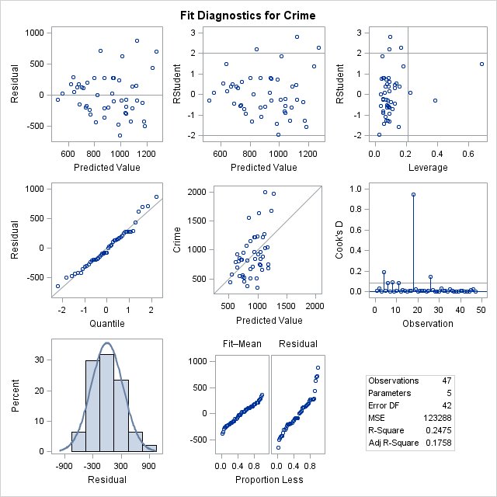

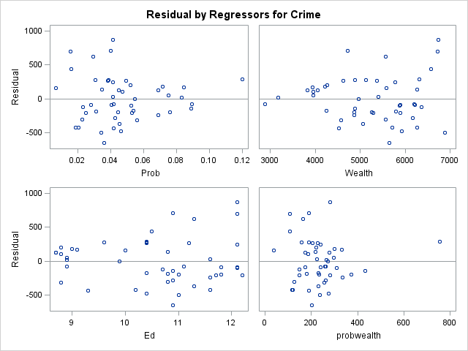

|  |
| --- |
| The SAS System |

The REG Procedure

Model: MODEL1

Dependent Variable: Crime

|  |  |
| --- | --- |
| **Number of Observations Read** | 47 |
| **Number of Observations Used** | 47 |

| **Analysis of Variance** | | | | | |
| --- | --- | --- | --- | --- | --- |
| **Source** | **DF** | **Sum of Squares** | **Mean Square** | **F Value** | **Pr > F** |
| **Model** | 3 | 1702734 | 567578 | 4.71 | 0.0062 |
| **Error** | 43 | 5178194 | 120423 |  |  |
| **Corrected Total** | 46 | 6880928 |  |  |  |

|  |  |  |  |
| --- | --- | --- | --- |
| **Root MSE** | 347.02032 | **R-Square** | 0.2475 |
| **Dependent Mean** | 905.08511 | **Adj R-Sq** | 0.1950 |
| **Coeff Var** | 38.34118 |  |  |

| **Parameter Estimates** | | | | | |
| --- | --- | --- | --- | --- | --- |
| **Variable** | **DF** | **Parameter Estimate** | **Standard Error** | **t Value** | **Pr > |t|** |
| **Intercept** | **1** | 101.36856 | 875.33813 | 0.12 | 0.9083 |
| **Prob** | **1** | 1976.89081 | 12865 | 0.15 | 0.8786 |
| **Wealth** | **1** | 0.18758 | 0.14933 | 1.26 | 0.2159 |
| **probwealth** | **1** | -1.16737 | 2.27227 | -0.51 | 0.6101 |

|  |
| --- |
| The SAS System |

The REG Procedure

Model: MODEL1

Dependent Variable: Crime

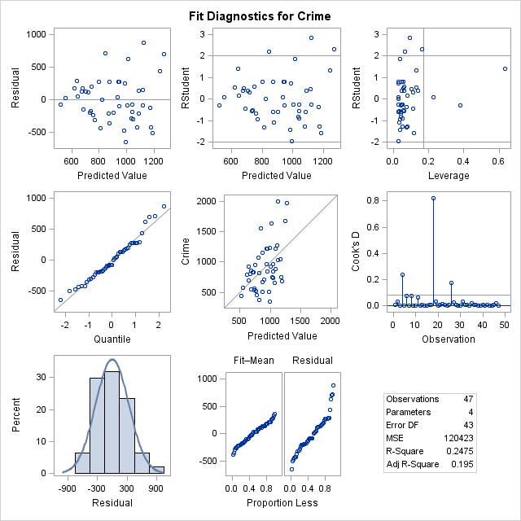

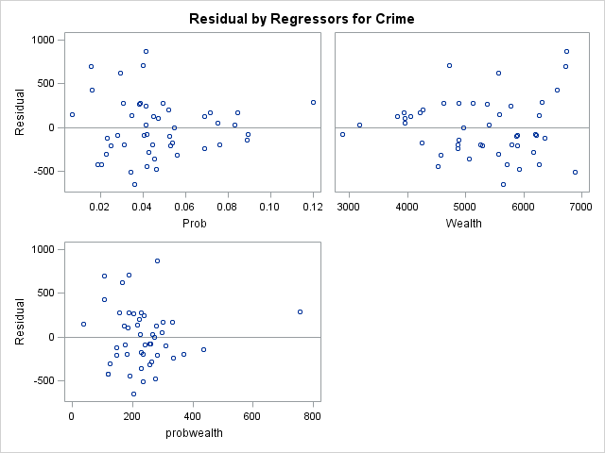

|  |
| --- |
| The SAS System |

The REG Procedure

Model: MODEL1

Dependent Variable: Crime

|  |  |
| --- | --- |
| **Number of Observations Read** | 47 |
| **Number of Observations Used** | 47 |

| **Analysis of Variance** | | | | | |
| --- | --- | --- | --- | --- | --- |
| **Source** | **DF** | **Sum of Squares** | **Mean Square** | **F Value** | **Pr > F** |
| **Model** | 5 | 3270485 | 654097 | 7.43 | <.0001 |
| **Error** | 41 | 3610443 | 88060 |  |  |
| **Corrected Total** | 46 | 6880928 |  |  |  |

|  |  |  |  |
| --- | --- | --- | --- |
| **Root MSE** | 296.74834 | **R-Square** | 0.4753 |
| **Dependent Mean** | 905.08511 | **Adj R-Sq** | 0.4113 |
| **Coeff Var** | 32.78679 |  |  |

| **Parameter Estimates** | | | | | |
| --- | --- | --- | --- | --- | --- |
| **Variable** | **DF** | **Parameter Estimate** | **Standard Error** | **t Value** | **Pr > |t|** |
| **Intercept** | **1** | -1279.72305 | 734.47269 | -1.74 | 0.0889 |
| **Prob** | **1** | -3061.80612 | 2283.11513 | -1.34 | 0.1873 |
| **ur** | **1** | 24.87030 | 9.20862 | 2.70 | 0.0100 |
| **Pop** | **1** | 0.10197 | 1.39310 | 0.07 | 0.9420 |
| **police** | **1** | 327.01446 | 128.48740 | 2.55 | 0.0148 |
| **Ed** | **1** | 121.52663 | 47.30601 | 2.57 | 0.0139 |

|  |
| --- |
| The SAS System |

The REG Procedure

Model: MODEL1

Dependent Variable: Crime

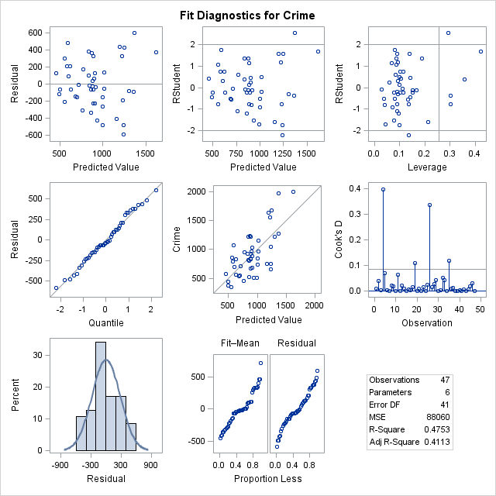

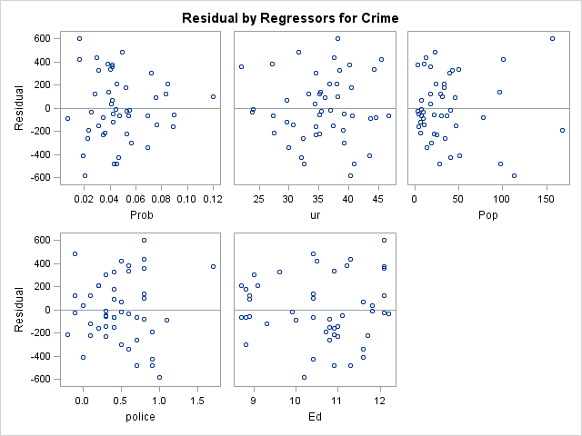

|  |
| --- |
| The SAS System |

The REG Procedure

Model: MODEL1

Dependent Variable: Crime

|  |  |
| --- | --- |
| **Number of Observations Read** | 47 |
| **Number of Observations Used** | 47 |

| **Analysis of Variance** | | | | | |
| --- | --- | --- | --- | --- | --- |
| **Source** | **DF** | **Sum of Squares** | **Mean Square** | **F Value** | **Pr > F** |
| **Model** | 4 | 3270013 | 817503 | 9.51 | <.0001 |
| **Error** | 42 | 3610914 | 85974 |  |  |
| **Corrected Total** | 46 | 6880928 |  |  |  |

|  |  |  |  |
| --- | --- | --- | --- |
| **Root MSE** | 293.21349 | **R-Square** | 0.4752 |
| **Dependent Mean** | 905.08511 | **Adj R-Sq** | 0.4253 |
| **Coeff Var** | 32.39623 |  |  |

| **Parameter Estimates** | | | | | |
| --- | --- | --- | --- | --- | --- |
| **Variable** | **DF** | **Parameter Estimate** | **Standard Error** | **t Value** | **Pr > |t|** |
| **Intercept** | **1** | -1282.40040 | 724.82318 | -1.77 | 0.0841 |
| **Prob** | **1** | -3109.00798 | 2164.06126 | -1.44 | 0.1582 |
| **ur** | **1** | 25.10677 | 8.52061 | 2.95 | 0.0052 |
| **police** | **1** | 329.09947 | 123.79762 | 2.66 | 0.0111 |
| **Ed** | **1** | 121.45277 | 46.73187 | 2.60 | 0.0128 |

|  |
| --- |
| The SAS System |

The REG Procedure

Model: MODEL1

Dependent Variable: Crime

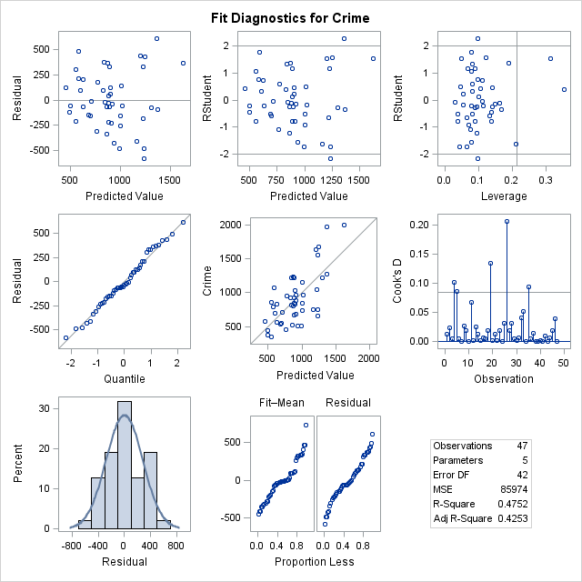

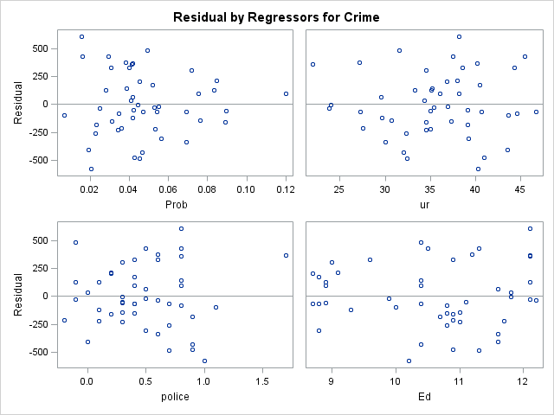

|  |
| --- |
| The SAS System |

The REG Procedure

Model: MODEL1

Dependent Variable: Crime

|  |  |
| --- | --- |
| **Number of Observations Read** | 47 |
| **Number of Observations Used** | 47 |

| **Analysis of Variance** | | | | | |
| --- | --- | --- | --- | --- | --- |
| **Source** | **DF** | **Sum of Squares** | **Mean Square** | **F Value** | **Pr > F** |
| **Model** | 3 | 2689307 | 896436 | 9.20 | <.0001 |
| **Error** | 43 | 4191621 | 97480 |  |  |
| **Corrected Total** | 46 | 6880928 |  |  |  |

|  |  |  |  |
| --- | --- | --- | --- |
| **Root MSE** | 312.21715 | **R-Square** | 0.3908 |
| **Dependent Mean** | 905.08511 | **Adj R-Sq** | 0.3483 |
| **Coeff Var** | 34.49589 |  |  |

| **Parameter Estimates** | | | | | |
| --- | --- | --- | --- | --- | --- |
| **Variable** | **DF** | **Parameter Estimate** | **Standard Error** | **t Value** | **Pr > |t|** |
| **Intercept** | **1** | 441.47546 | 311.16967 | 1.42 | 0.1632 |
| **Prob** | **1** | -5526.95094 | 2080.49823 | -2.66 | 0.0110 |
| **ur** | **1** | 15.37169 | 8.14909 | 1.89 | 0.0660 |
| **police** | **1** | 370.34203 | 130.73365 | 2.83 | 0.0070 |
|  |  |  |  |  |  |

|  |
| --- |
| The SAS System |

The REG Procedure

Model: MODEL1

Dependent Variable: Crime

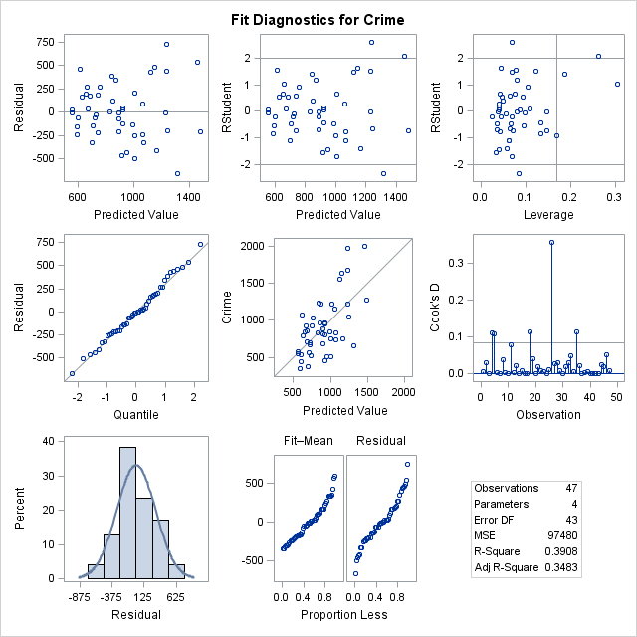

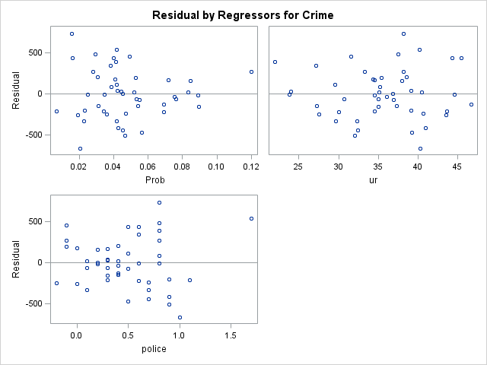

|  |
| --- |
| The SAS System |

The REG Procedure

Model: MODEL1

Dependent Variable: Crime

|  |  |
| --- | --- |
| **Number of Observations Read** | 47 |
| **Number of Observations Used** | 47 |

| **Analysis of Variance** | | | | | |
| --- | --- | --- | --- | --- | --- |
| **Source** | **DF** | **Sum of Squares** | **Mean Square** | **F Value** | **Pr > F** |
| **Model** | 3 | 2523550 | 841183 | 8.30 | 0.0002 |
| **Error** | 43 | 4357377 | 101334 |  |  |
| **Corrected Total** | 46 | 6880928 |  |  |  |

|  |  |  |  |
| --- | --- | --- | --- |
| **Root MSE** | 318.33058 | **R-Square** | 0.3667 |
| **Dependent Mean** | 905.08511 | **Adj R-Sq** | 0.3226 |
| **Coeff Var** | 35.17134 |  |  |

| **Parameter Estimates** | | | | | |
| --- | --- | --- | --- | --- | --- |
| **Variable** | **DF** | **Parameter Estimate** | **Standard Error** | **t Value** | **Pr > |t|** |
| **Intercept** | **1** | 274.52087 | 538.67095 | 0.51 | 0.6129 |
| **Prob** | **1** | -4546.49559 | 2288.96110 | -1.99 | 0.0534 |
| **police** | **1** | 422.03946 | 129.96680 | 3.25 | 0.0023 |
| **Ed** | **1** | 60.91757 | 45.56942 | 1.34 | 0.1883 |

|  |
| --- |
| The SAS System |

The REG Procedure

Model: MODEL1

Dependent Variable: Crime

